**DBMS LAB**

**Lab Experiment number 04**

**Name:** Aamir Ansari **Batch:** A **Roll no.** 01

**Aim:** Experiment to study Data Manipulation Language Commands.

**Theory:**

The Data Manipulation Language (DML) is used to retrieve, insert and modify

database information. These commands will be used by all database users during the routine

operation of the database. Let’s take a brief look at the basic DML commands:

INSERT

The INSERT command in SQL is used to add records to an existing table. Returning to the

personal_info example from the previous section, let&#39;s imagine that our HR department needs

to add a new employee to their database. They could use a command similar to the one shown

below:

**Syntax:** insert into table tablename values(values);

**Example:**

INSERT INTO employee

values(‘bart’, ‘simpson’, 12345, $45000)

These correspond to the table attributes in the order they were defined: first_name,

last_name, employee_id, and salary.

SELECT

The SELECT command is the most commonly used command in SQL. It allows database

users to retrieve the specific information they desire from an operational database. Let’s take

a look at a few examples, again using the personal_info table from our employees database.

**Syntax:** select <attribute list> from <list if tables> where predicate;

**Example:**

SELECT * FROM employee

Alternatively, users may want to limit the attributes that are retrieved from the database. For

example, the Human Resources department may require a list of the last names of all

employees in the company. The following SQL command would retrieve only that

information.

**SELECT last_name FROM employee**

Finally, the WHERE clause can be used to limit the records that are retrieved to those that

meet specified criteria.

SELECT *FROM employee WHERE salary &gt; 50000

UPDATE

The UPDATE command can be used to modify information contained within a table, either

in bulk or individually.

**Syntax:** update tablename set predicate;

**Example:**

UPDATE employee SET salary = salary * 1.03

On the other hand, our new employee Bart Simpson has demonstrated performance above

and beyond the call of duty. Management wishes to recognize his stellar accomplishments

with a $5,000 raise. The WHERE clause could be used to single out Bart for this raise:

UPDATE employee SET salary = salary + $5000

WHERE employee_id = 12345

Give 10 % raise in salary who are working on railway project and working for IT department

Update employee set salary=salary*1.1 where dno=(select dno from dept where dname=”it”)

and ssn=(select ssn from workson where pno=(select pno from project where

pname=”railway”))

DELETE

The DELETE command with a WHERE clause can be used to remove his record from the

employee table:

**Syntax:** delete from tablename where predicate;

**Example:**

DELETE FROM employee WHERE employee_id = 12345

Delete employees working for IT department

Delete from employee where dno=(select dno from dept where dname=”IT”)

**Code:**

-- Insert value in department table

INSERT INTO Department (d_no, d_name, mgr_ssn, mgr_start_date)

VALUES (

5,

'Research',

NULL,

'1988-05-22'

),

(

4,

'Administration',

NULL,

'1995-01-01'

),

(

1,

'Headquarters',

NULL,

'1981-06-19'

)

SELECT * FROM Department;

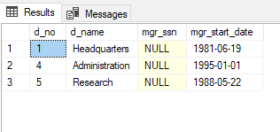.

-- Insert values in employee table

INSERT INTO Employee (f_name, m_name, l_name, ssn, dob, addr, sex, salary, super_ssn, d_no)

VALUES (

'John', 'B', 'Smith',

123456789,

'1965-01-09',

'731 Fondren, Houston, TX',

'M',

30000,

NULL,

5

),

(

'Franklin', 'T', 'Wong',

33344555,

'1955-12-08',

'638 Voss, Houston, TX',

'M',

40000,

NULL,

5

),

(

'Alicia', 'J', 'Zelaya',

999887777,

'1968-01-19',

'3321 Castle, Spring, TX',

'F',

25000,

NULL,

4

),

(

'Jennifer', 'S', 'Wallace',

987654321,

'1941-06-20',

'291 Berrym, Bellaire, TX',

'F',

43000,

NULL,

4

),

(

'Ramesh', 'K', 'Narayan',

666884444,

'1962-09-15',

'975 Fire Oak, Humble, TX',

'M',

38000,

NULL,

5

),

(

'Joyce', 'A', 'English',

453453453,

'1972-07-31',

'5361 Rice, Houston, TX',

'F',

25000,

NULL,

5

),

(

'Ahmad', 'V', 'Jabbar',

987987987,

'1969-03-29',

'980 Dallas, Houston, TX',

'M',

25000,

NULL,

4

),

(

'James', 'E', 'Borg',

888665555,

'1937-11-10',

'450 Stone, Houston, TX',

'M',

55000,

NULL,

1

)

SELECT * FROM Employee;

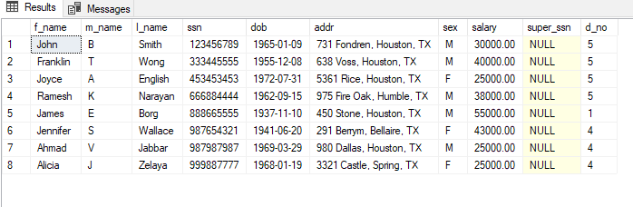.

-- Insert foreign key super_ssn in Emplyee table

UPDATE Employee SET super_ssn = 333445555

WHERE ssn = 123456789;

UPDATE Employee SET super_ssn = 888665555

WHERE ssn = 333445555;

UPDATE Employee SET super_ssn = 987654321

WHERE ssn = 999887777;

UPDATE Employee SET super_ssn = 888665555

WHERE ssn = 987654321;

UPDATE Employee SET super_ssn = 333445555

WHERE ssn = 666884444;

UPDATE Employee SET super_ssn = 333445555

WHERE ssn = 453453453;

UPDATE Employee SET super_ssn = 987654321

WHERE ssn = 987987987;

SELECT * FROM Employee

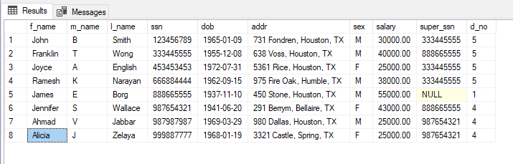.

-- Insert foreign key mgs_ssn in Department Table

UPDATE Department SET mgr_ssn = 333445555

WHERE d_no = 5;

UPDATE Department SET mgr_ssn = 987654321

WHERE d_no = 4;

UPDATE Department SET mgr_ssn = 888665555

WHERE d_no = 1;

SELECT * FROM Department

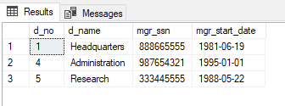.

-- Insert values in Department_location table

INSERT INTO Department_location(d_no, d_location)

VALUES (

1, 'Houston'

),

(

4, 'Stafford'

),

(

5, 'Bellaire'

),

(

5, 'Sugarland'

),

(

5, 'Houston'

)

SELCT * FROM Department_location;

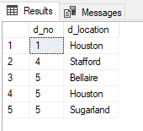.

-- Insert values in Project table

INSERT INTO Project(p_no, p_name, p_location, d_no)

VALUES (

1, 'ProjuctX', 'Bellaire', 5

),

(

2, 'ProductY', 'Sugarland', 5

),

(

3, 'ProductZ', 'Houston', 5

),

(

10, 'Computerization', 'Stafford', 4

),

(

20, 'Reorganisation', 'Houston', 1

),

(

30, 'Newbenefits', 'Stafford', 4 )

SELECT * FROM Project

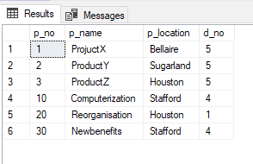.

-- Insert values in Works_on table

INSERT INTO Works_on (e_ssn, p_no, hours_worked)

VALUES (

123456789, 1, 32.5

),

(

123456789, 2, 7.5

),

(

666884444, 3, 40.0

),

(

453453453, 1, 20.0

),

(

453453453, 2, 10.0

),

(

333445555, 2, 10.0

),

(

333445555, 3, 10.0

),

(

333445555, 10, 10.0

),

(

333445555, 20, 10.0

),

(

999887777, 30, 30.0

),

(

999887777, 10, 10.0

),

(

987987987, 10, 35.0

),

(

987987987, 30, 3.0

),

(

987654321, 30, 20.0

),

(

987654321, 20, 15.0

),

(

888665555, 20, NULL

)

SELECT * FROM Works_on

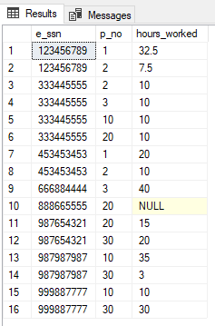.

--Insert values into Dependant table

INSERT INTO Dependant(e_ssn, dependent_name, dependent_sex, dependent_dob, dependent_relation)

VALUES (

333445555, 'Alice',

'F',

'1986-04-05',

'Daughter'

),

(

333445555, 'Theodore',

'M',

'1983-10-25',

'Son'

),

(

333445555, 'Joy',

'F',

'1958-05-03',

'Spouse'

),

(

987654321, 'Abner',

'M',

'1942-02-28',

'Spouse'

),

(

123456789, 'Michael',

'F',

'1988-01-04',

'Son'

),

(

123456789, 'Alice',

'F',

'1988-12-30',

'Daughter'

),

(

123456789, 'Elizabeth',

'F',

'1967-05-05',

'Spouse'

)

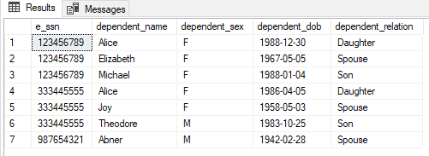.

**Conclusion:** Thus we have implemented different DML commands successfully.